**Project Design Phase-II Technology Stack (Architecture & Stack)**

|  |  |
| --- | --- |
| Date | 30 June 2025 |
| Team ID | LTVIP2025TMID37158 |
| Project Name | Transfer Learning-Based Classification of  Poultry Diseases for Enhanced Health  Management |
| Maximum Marks | 4 Marks |

**Technical Architecture:**

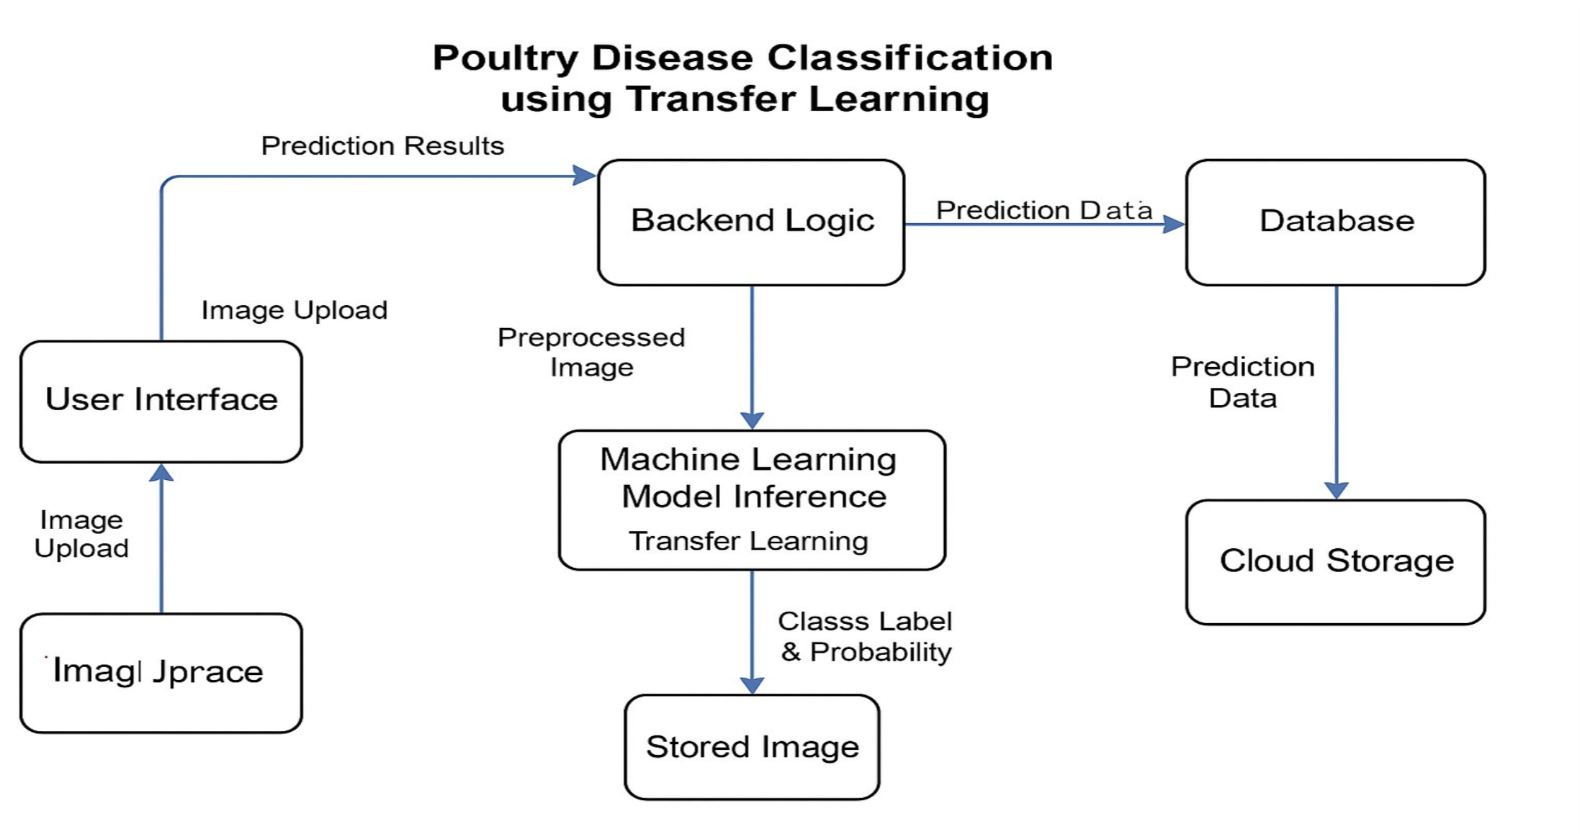

|  |  |  |  |
| --- | --- | --- | --- |
| **S.No** | **Characteristics** | **Description** | **Technology** |
| 1. | Open-Source Frameworks | ML model training and inference | TensorFlow / Keras / PyTorch |
| 2. | Security Implementations | Image upload security, access controls, API key restrictions | HTTPS, SHA-256, API Gateway |
| 3. | Scalable Architecture | Microservice-based model deployment for easy scaling | Docker, Kubernetes (if used) |

**Table-1 : Components & Technologies:**

|  |  |  |  |
| --- | --- | --- | --- |
| **S.No** | **Component** | **Description** | **Technology** |
| 1. | User Interface | Frontend for users to upload poultry images and view results | HTML, CSS, JavaScript |
| 2. | Application Logic-1 | Handles image preprocessing and routing requests | Python (Flask / Django) |
| 3. | Application Logic-2 | Disease prediction using trained CNN/Transfer Learning model | TensorFlow / PyTorch |
| 4. | Application Logic-3 | Model management and probability output parsing | Python |
| 5. | Database | Stores user details, prediction history, and logs | MySQL / SQLite |
| 6. | Cloud Database | Cloud storage of logs and results | Firebase / IBM Cloudant |
| 7. | File Storage | Temporary storage of uploaded images | AWS S3 / Local File System |
| 8. | External API-1 | Optional: Weather data for poultry care advisory | OpenWeatherMap API |
| 9. | External API-2 | Optional: Disease news updates or vet services | News API / Vet API (if used) |
| 10. | Machine Learning Model | Classifies poultry images into 4 disease categories | MobileNet / ResNet (via Transfer Learning) |
| 11. | Infrastructure (Server / Cloud) | Deployment on cloud or local server | Localhost / AWS / IBM Cloud |

**Table-2: Application Characteristics:**

|  |  |  |  |
| --- | --- | --- | --- |
| **S.No** | **Characteristics** | **Description** | **Technology** |
| 4. | Availability | Can be hosted on cloud with failover or load balancing | AWS EC2 / Cloud Load Balancer |
| 5. | Performance | Uses image caching and lightweight models for fast inference | Redis (optional), CDN (optional) |